 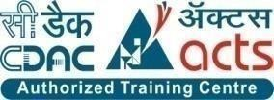

**INSTITUTE FOR ADVANCED COMPUTING AND SOFTWARE DEVELOPMENT AKURDI, PUNE**

Documentation On

“Helping Needy Ones”

PG-DAC SEPT 2022

**Submitted By:**

**Group No: 42**

# Sahastranshu Kushwaha(229079)

# Utkarsh Upadhyay(229107)

**Mrs. Gauri Kadam Mr. Rohit Puranik**

**Project Guide Centre Coordinator**

# 

# ABSTRACT

This project is a web-based application where donor can donate either in the form of monetary help or any item like books, clothes, e-items, toys etc.

By providing this platform, the donor can just register their details and donate any item they want to the needy and make the donation by just clicking according to the category provided in the system. For item donation, donor has to first fill out the form where he has to provide the type of donation and picture of the donated item and handover it over to the employee. If donor wants to help monetary then will be redirected to the payment page.

With the donated money, tender will be generated automatically if the collected donation is above specific amount, different venders can bid on it and selected vendor will get the order. Vendor will deliver the item and then money is transferred.

Employee will collect the donated items form the donor and also collect item that is delivered by the vendor. Employee then deliver the item to the needy children and take picture with the child. Employee then upload the picture of giving item to the child in the database.

By providing this application, donors can easily donate without worrying the money or donations go to the wrong channel.

# ACKNOWLEDGEMENT

I take this occasion to thank God, almighty for blessing us with his grace and taking our endeavor to a successful culmination. I extend my sincere and heartfelt thanks to our esteemed guide, **Mrs. Gauri Kadam** for providing me with the right guidance and advice at the crucial time for showing me the right way. I extend my sincere thanks to our respected **Centre Co-Ordinator Mr. Rohit Puranik**, for allowing us to use the facilities available. I would like to thank the other faculty members also, at this occasion. Last but not the least, I would like to thank my friends and family for the support and encouragement they have given me during the course of our work.

**Sahastranshu Kushwaha(229079)**

**Utkarsh Upadhyay (229107)**

**Table of Contents**

ABSTRACT 2

ACKNOWLEDGEMENT 3

INTRODUCTION 7

FEATURES 7

* 1. PROJECT OBJECTIVE 8
  2. PROJECT OVERVIEW 8
  3. PROJECT SCOPE 9
  4. STUDY OF THE SYSTEM 9
     1. MODULES 9

SYSTEM ANALYSIS…………………………………………………………………………..12

* 1. EXISTING SYSTEM……………………………………………………………………….12
  2. PROPOSED SYSTEM……………………………………………………………………...12
  3. SYSTEM REQUIREMENT SPECIFICATION 13
     1. GENERAL DESCRIPTION 14
     2. SYSTEM OBJECTIVES 14
     3. SYSTEM REQUIREMENTS 14

MODERATOR 17

DESCRIPTION OF FEATURES 17

EMPLOYEE 17

SYSTEM DESIGN 18

* 1. INPUT AND OUTPUT DESIGN 18
     1. INPUT DESIGN 18
     2. OUTPUT DESIGN 19

DATABASE DESIGN 19

* 1. DATABASE 19
  2. SYSTEM TOOLS 19
     1. FRONT END 19
     2. BACKEND 20

E-R SYSTEM GENERATED DIAGRAM 21

E-R MANUAL DIAGRAM 22

CLASS DIAGRAM 23

1 LEVEL DONOR DFD DIAGRAM 24

1 LEVEL VENDOR DFD DIAGRAM 25

1 LEVEL EMPLOYEE DFD DIAGRAM 26

ANONYMOUS DONOR ACTIVITY DIAGRAM 27

DONOR ACTIVITY DIAGRAM 28

VENDOR ACTIVITY DIAGRAM 29

EMPLOYEE ACTIVITY DIAGRAM 30

USE CASE DIAGRAM 31

SEQUENCE DIAGRAM 32

TABLE STRUCTURE………………………………………………………………………….33-36

PROJECT SCREENSHORT…………………………………………………………………..37-39

CONCLUSION 40

FUTURE SCOPE 41

REFERENCES 42

**LIST OF FIGURES**

**FIGURE 1: E-R SYSTEM GENERATED DIAGRAM 21**

**FIGURE 2: E-R MANUAL DIAGRAM 22**

**FIGURE 3: CLASS DIAGRAM -23**

**FIGURE 4: 1 LEVEL DONOR DFD DIAGRAM 24**

**FIGURE 5: 1 LEVEL VENDOR DFD DIAGRAM 25**

**FIGURE 6: 1 LEVEL EMPLOYEE DFD DIAGRAM 26**

**FIGURE 7: ANONYMOUS DONOR ACTIVITY DIAGRAM 27**

**FIGURE 8: DONOR ACTIVITY DIAGRAM 28**

**FIGURE 9: VENDOR ACTIVITY DIAGRAM 29**

**FIGURE 10: EMPLOYEE ACTIVITY DIAGRAM 30**

**FIGURE 11: USE CASE DIAGRAM 31**

**FIGURE 12: SEQUENCE DIAGRAM 32**

# INTRODUCTION

IACSD Helping Needy Ones

This project is a web-based application where donor can donate either in the form of monetary help or any items like books, clothes e-items, toys etc. If the donor wants to provide monetary help then donor will be directed to the payment gateway page. For item donation, donor has to sign up, fill in details like Name, Address, etc. in the form, select the item various categories like books, cloths, e-items, toys etc., upload picture of donated item in the form and then handover the item to the employee.  After this the employee will collect the item and the employee will distribute it to the needy ones and he will take a picture with the donee this will be visible to only employees. We are doing this for increasing privacy and transparency purpose. With the donated money employee will raise the bids for books, clothes, etc. and the best of 5 vendors on the basis of quality 1 will be selected, after receiving the items the money will be transferred automatically to the vendors and every month to the salary of employee will be transferred automatically.

The project objective is to deliver the basic items like notebooks, clothes etc. to the needy specifically children. Helps to regrow the emotions in a person and by donating, one’s life will be improved and donor will feel self-satisfaction by doing this kind thing. Help the local vendors by promoting their business through the process of this project .A complete and efficient web application which can provide the user friendly donation facility and transparency in donation is the basic objective of the project.

**Features:** -

1. Category of items for donation-Books, Clothes, Toys, E-Items etc.
2. Anonymous donor can donate money also
3. Vendor bids for tender available.
4. Employee select the best vendor and collect the items and distribute the item to the donee.
5. 24x7 online money donation available.

IACSD Helping Needy Ones

* 1. **PROJECT OBJECTIVE**

The project objective is to deliver the basic items like notebooks, clothes etc. to the needy specifically children. Helps to regrow the emotions in a person and by donating, one’s life will be improved and donor will feel self-satisfaction by doing this kind thing. Help the local vendors by promoting their business through the process of this project .A complete and efficient web application which can provide the user friendly donation facility and transparency in donation is the basic objective of the project.

* 1. **PROJECT OVERVIEW**

The central concept of the application is to allow the donor to donate items by filling the form online and handover item to employee or donor can provide monetary help by donating money through the payment page provided in the application. With the donated money, the tender is released automatically in the vendor page at the starting of month (note that after deducting the employee salary if the remaining donated money satisfies the minimum amount needed for tender then only the tender will be released automatically) and bids for items will be raised by the employee and top 5 vendors will be selected and from this 5 vendors the best vendor is selected according to price and quality by the employee. After receiving the items the money will be transferred automatically to the vendors and every month the salary of employee will be transferred automatically.

Picture of item distributed to needy children by the employee is not shown in the website due to privacy of donee .The employee maintains and updates the information pertaining to the donated items and maintains the database.

* 1. **PROJECT SCOPE**

IACSD Helping Needy Ones

This website provides a platform where donors can donate in the form of money or via donating items, from which needy people can be benefitted. This website has the facility of anonymous donors who can donate monetarily and direct donors who can donate monetarily as well as by providing items like books, clothes, e-items, toys etc. The website the facility to accept the money donation 24X7 where the donor can donate the money any time.

* 1. **STUDY OF THE SYSTEM**

## MODULES:

The system after careful analysis has been identified to be presented with the following modules and roles.

The modules involved are:

* + - * Employee
      * Vendors
      * Donors
      1. Employee:

The Employee will sign up and then sign in/login. Employee have all the details of vendor and donor. Employee maintains the database. Employee collects the items form donor directly or from the item that is supplied by vendor. Employee distributes the items to the donee/needy children and takes picture of them with item but cannot show it in the website for the privacy of done.

This module is divided into different sub modules.

* + - * 1. Manage donors

IACSD Helping Needy Ones

* + - * 1. Manage Vendors
        2. Manage Items

**Features of Employee:-**

* **Employee signup and login**

Employee will sign up and then login. Employee will get all information in his dashboard only after the login.

* **Update Items**

Employee update the item status whether it is received or not.

* **Delete Vendor**

Employee can delete the vendor.

* **Maintains database**

Employee maintains all the data of items, vendor, donor, donee etc. in the database.

**Features of Donor:-**

* **Donor signup and login**

Donor can donate money with or without sign up but to donate items sign up is must.

* **Item type**

Donor can select items like books, clothes, e-items, toys etc. to donate.

* **Image of donated item**

Donor take picture of item and handover the item to the employee.

* P**ayments**

For donating money the donor will be redirected to the payment page.

**Features of Vendor:-**

IACSD Helping Needy Ones

* + **Vendor sign up and login**

This feature is provided to vendor so he can sign up and login

* + **Bid for items**

Vendor will get the tender automatically at the start of the month after login. By

Clicking on tender link a form will be opened for every item in which vendor

Wants to bid, after that he entered the amount which is feasible for the bid.

* + **Payments**

When the items get delivered the employee will check if the quantity obtained is

Right and then employee click on payment, money will be automatically transferred

To the bank account of the vendor.

IACSD Helping Needy Ones

# SYSTEM ANALYSIS

System analysis is the process of gathering and interpreting facts, diagnosing problems, and using the information to recommend improvements on the system. System analysis is a problem-solving activity that requires intensive communication between the system users and system developers.

System analysis or study is an important phase of any system development process. The system is viewed as a whole, the inputs are identified, and the system is subjected to close study to identify the problem areas. The solutions are given as a proposal. The proposal is reviewed on user request and suitable changes are made. This loop ends as soon as the user is satisfied with the proposal.

* 1. **EXISTING SYSTEM**

The current system for donation is not be easily accessible to everyone who wants to donate items,

Inefficient in terms of time and resources, only reach a limited audience and lack transparency in

Terms of how the donated items are used and distributed.

* + - It is less user-friendly.
    - Local vendor is not promoted.
    - Donor doesn’t know if there donated money is utilized wisely or not.
    - It have Limited reach.
    - It have limited hours of operation.
    - Tender is not released for biding for items.
  1. **PROPOSED SYSTEM**

In the proposed system donor can donate the money 24x7 online, vendor will bid for items that is going to be supplied to employee this make the money utilization more transparent. Anonymous donor can directly goes to payment page to donate money. Employee will update the details of items donated in the database with the picture with needy children but picture will not be available for anyone to show the respect of privacy of child.

* 1. **SYSTEM REQUIREMENT SPECIFICATION**

IACSD Helping Needy Ones

* + 1. **GENERAL DESCRIPTION**

**Product Description:**

The system consists of two parts: one for monetary donations and another for item donations. Donors can choose to donate money or they can choose to donate specific items that are needed by the needy. For monetary donations, donors can select the amount they wish to donate. For item donations, donors can browse a list of needed items provided in the form and select the items they wish to donate. They can then handover the items to the employee.

**Problem Statement:**

Many people wants to donate money or items but many donation websites are difficult to navigate, making it challenging for potential donors to make donations. Donors may be hesitant to provide personal and financial information online, especially if they are unsure of the website's security measures. Donors may not feel connected to the organization or cause they are donating to, which can reduce their likelihood of making future donations. Our proposed solution is to develop a donation website that addresses these problems by providing a user-friendly interface, robust security measures, and effective engagement strategies. The website will be designed with the user experience in mind, making it easy and intuitive for donors to navigate and make donations. The website will also implement the latest security measures to protect donors' personal and financial information. To increase engagement and connection with donors, the website will feature compelling visuals, impactful storytelling, and clear communication about the organization's goals and impact.

* + 1. **SYSTEM OBJECTIVES**
       - To provide a Web application for online donation of money and if want to donate money fill details of items online and handover the item to employee.
       - To provide a platform for local vendor to promote their business.

IACSD Helping Needy Ones

* + 1. **SYSTEM REQUIREMENTS**
       1. **NON-FUNCTIONAL REQUIREMENTS**

1. **Transparency:**

Our purpose is to make the website fully transparent so that everyone can know how many donations happen till the date.

### **Culture:**

This website also helps to regrow the emotions in a person and lets them know that by donating, one's life will be improved and also the donator feels good. This creates a culture of helping humans and it makes society a better place.

### **Automation:**

When the donor donates the item, he/she will get an e-receipt in their mail. Vendors get order details either through email or a message from the employee. When the vendor delivers the items, the employee has to submit the form, and then automatic payment will be made.

### **Helping:**

When we help the needy, it gives them moral support, and showing heartfelt humility and respect makes them aware that someone really cares about them and is trying to improve their condition and fulfill one of the necessities of life: Roti, Kapada aur Makan. Helping people who are in need gives them the inner peace. It will boost our self-esteem. Our motto is not only to help the needy people, but also to help the local vendors improve their business and expand their business.

### **v) Availability:**

We just created our website. If any person wants to donate money, then he/she can donate at any time throughout the year. So that there is no time boundary and whichever time the donor feels comfortable, he/she can donate the money.

### **vi) Money Management:**

When the person donates the money monthly, it gives the donor a sense of responsibility. Also, by donating the money monthly, the donor knows how to manage money and take out some for the donation. It also improves the person's money management.

**vii) Give, If You Can’t give time:**

IACSD Helping Needy Ones

When you’re too busy or not able to donate your time, giving money is the perfect workaround. Never think that you can’t improve someone’s life or the world itself if your personal or professional schedule won’t allow the time.

### **viii) Ease to use:**

Our website is formed in just a way that any person who knows how to operate the internet can easily access it without any difficulty.

### **ix) Implementation:**

Implementation of the system using React at the front-end with Java/dotnet as the back end and it will be used for database connectivity. And the database part is developed by MySql. Responsive web designing is used for making the website compatible for any type of screen. Systems can be deployed to a single server, multi servers, to any OS, Cloud (Azure or AWS or GCP).

### **x) Security:**

SHA-512, or Secure Hash Algorithm 512, is used to convert text of any length into a fixed-size string. This algorithm is used for email address hashing, password hashing etc. Unauthorized people cannot access the website and database and do not read and write the information.

### **xi) Session Management:**

Session management is used to securely handle multiple requests to a web-based application or service from a single user or entity.

* + - 1. **FUNCTIONAL REQUIREMENTS**

An anonymous donor can donate monetarily only, But after login, the donor can donate money as well as items.

The anonymous donors can donate money directly from the website home page link, which will redirect the donor to the webpage from where they can transfer the donation amount to our bank account.

The donors who want to donate money after signing in, their details will be stored and they can transfer the donation amount to our bank account. Those who want to donate items have to fill in the details about the product and then apply for a donation.

Vendors get information on our website about tenders. The tender is released automatically on the 1st day of the month when the amount obtained through donation has fulfilled the minimum

amount needed for the tender to be released. After the tender is released, the vendor can see the information about the tender on our website and can bid for the tender after login.

IACSD Helping Needy Ones

Now, after the bidding process, the top 5 contenders will be shortlisted automatically and our employee physically visits the 5 contenders and tests the quality with price, then the employee will select one vendor from which we will get the items. Now the whole delivery will be received at our warehouse.

The employee will receive the delivery as per the details at the warehouse and update the status. When any donor wants to donate any item, then, as he uploads the item details, then our employee gets a status for approval or hold. When the donor donates the item at our warehouse, then the employee receives the donated items and then he approves the request of the donator to then, automatically, a receipt is generated and sent via email.

The employee maintains the details about donated items, generates receipts, and also takes images of donated items with the person. The database is maintained about how many donations happened till the date and how many people benefited from this process.

IACSD Helping Needy Ones

# MODERATOR

**Description of features**

A moderator is considered as a staff who can manage donated items for the time being here in our project it is employee. Moderator has all the privilege except have access of this welfare trust bank account. He can manage donors, vendors and manage items for donation. He can also check the pending items that he got from donor or vendor and not delivered items to needy.

**Functional Requirement**

* The system must identify the login of a moderator.

**EMPLOYEE**

* **MANAGE DONOR**

**Description of features**

The employee can see donor details, item type, no. of items donated by the donor.

* **MANAGE VENDOR**

**Description of features**

The administrator can see vendor details, delete vendor, item supplied by vendor and if money is transfer to vendor or not.

* **MANAGE ITEMS**

**Description of features**

The administrator can know if the item obtained from donor or supplied by vendor. Also if the item is in pending state from donor or received by employee and if item is delivered to done or not.

IACSD Helping Needy Ones

**Functional Requirements:**

* The system must identify the login of the employee.
* Employee account should be secured so that only employee shop can access that account.

# SYSTEM DESIGN

System design is the solution for the creation of a new system. This phase focuses on the detailed implementation of the feasible system. Its emphasis on translating design. Specifications to performance specification. System design has two phases of development.

* Logical Design
* Physical Design

During logical design phase the analyst describes inputs (sources), outputs (destinations), databases (data sores) and procedures (data flows) all in a format that meets the user requirements. The analyst also specifies the needs of the user at a level that virtually determines the information flow in and out of the system and the data resources. Here the logical design is done through data flow diagrams and database design. The physical design is followed by physical design or coding. Physical design produces the working system by defining the design specifications, which specify exactly what the candidate system must do. The programmers write the necessary programs that accept input from the user, perform necessary processing on accepted data and produce the required report on a hard copy or display it on the screen.

* 1. **INPUT AND OUTPUT DESIGN**
     1. **INPUT DESIGN:**

Input design is the link that ties the information system into the world of its users. The input design involves determining the inputs, validating the data, minimizing the data entry and provides a multi-user facility. Inaccurate inputs are the most common cause of errors in data processing. Errors entered by the data entry operators can be controlled by input design. The user-originated inputs are converted to a computer-based format in the input design. Input data are collected and organized into groups of similar data. Once identified, the appropriate input media are selected for processing. All the input data are validated and if any data violates any conditions, the user is warned by a message. If the data satisfies all the conditions, it is transferred to the appropriate tables in the database. A page is designed for this purpose which is user friendly and easy to use. The design is done such that users get appropriate messages when exceptions occur.

* + 1. **OUTPUT DESIGN:**

IACSD Helping Needy Ones

Computer output is the most important and direct source of information to the user. Output design

is a very important phase since the output needs to be in an efficient manner. Efficient and intelligible output design improves the system relationship with the user and helps in decision making. Allowing the user to view the sample screen is important because the user is the ultimate judge of the quality of output. The output module of this system is the selected notifications.

# DATABASE DESIGN

* 1. **DATABASE**

Databases are the storehouses of data used in the software systems. The data is stored in tables inside the database. Several tables are created for the manipulation of the data for the system. Two essential settings for a database are

* Primary key - the field that is unique for all the record occurrences
* Foreign key - the field used to set relation between tables Normalization is a technique to avoid redundancy in the tables.
  1. **SYSTEM TOOLS**

The various system tools that have been used in developing both the front end and the back end of the project are being discussed in this chapter.

* + 1. **FRONT END:**

React is a library which is developed by Facebook are utilized to implement the frontend. React (also known as React.js or ReactJS) is a [free and open-source](https://en.wikipedia.org/wiki/Free_and_open-source_software) [front-end](https://en.wikipedia.org/wiki/Front_end_and_back_end) [JavaScript](https://en.wikipedia.org/wiki/JavaScript_library) [library](https://en.wikipedia.org/wiki/JavaScript_library) for building [user interfaces](https://en.wikipedia.org/wiki/User_interfaces) or UI components. It is maintained by [Facebook](https://en.wikipedia.org/wiki/Facebook%2C_Inc) and a community of individual developers and companies. React can be used as a base in the development of [single](https://en.wikipedia.org/wiki/Single-page_application) [page](https://en.wikipedia.org/wiki/Single-page_application) or mobile applications. However, React is only concerned with state management and rendering that state to the [DOM,](https://en.wikipedia.org/wiki/Document_Object_Model) so creating React applications usually requires the use of additional libraries for routing, as well as certain client-side functionality.

* + 1. **BACKEND:**

IACSD Helping Needy Ones

The back end is implemented using MySQL which is used to design databases.

**MySQL:**

MySQL is the world's second most widely used open-source relational database management system (RDBMS). The SQL phrase stands for Structured Query Language. An application software called Navicert was used to design the tables in MySQL.

**Spring-Boot:**

This is used to connect MYSQL and fetch data from database and store the data in database. The Spring Framework is a[n application framework](https://en.wikipedia.org/wiki/Application_framework) and [inversion of control](https://en.wikipedia.org/wiki/Inversion_of_control) [container](https://en.wikipedia.org/wiki/Servlet_container) for the [Java](https://en.wikipedia.org/wiki/Java_platform) [platform.](https://en.wikipedia.org/wiki/Java_platform) The framework's core features can be used by any Java application, but there are extensions for building web applications on top of the [Java EE](https://en.wikipedia.org/wiki/Java_EE) (Enterprise Edition) platform. Although the framework does not impose any specific [programming model,](https://en.wikipedia.org/wiki/Programming_model) it has become popular in the Java community as an addition to the [Enterprise JavaBeans](https://en.wikipedia.org/wiki/Enterprise_JavaBeans) (EJB) model. The Spring Framework is Open-source Framework.

**Spring Boot JPA:**

**Spring Boot JPA**is a Java specification for managing **relational** data in Java applications. It allows us to access and persist data between Java object/ class and relational database.JPA follows **Object-Relation Mapping**(ORM). It is a set of interfaces. It also provides a runtime **Entity Manager**API for processing queries and transactions on the objects against the database. It uses a platform-independent object-oriented query language JPQL (Java Persistent Query Language)

IACSD Helping Needy Ones

# E-R System generated diagram:

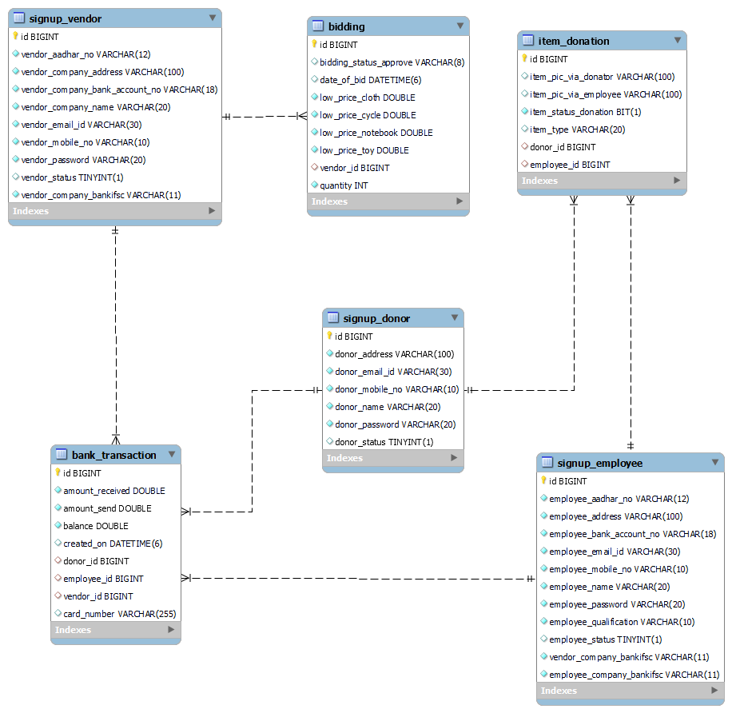

***Figure 1 E-R system generated diagram***

# E-R Manual diagram:

IACSD Helping Needy Ones

# 

***Figure 2 E-R manual diagram***

IACSD Helping Needy Ones

# Class Diagram

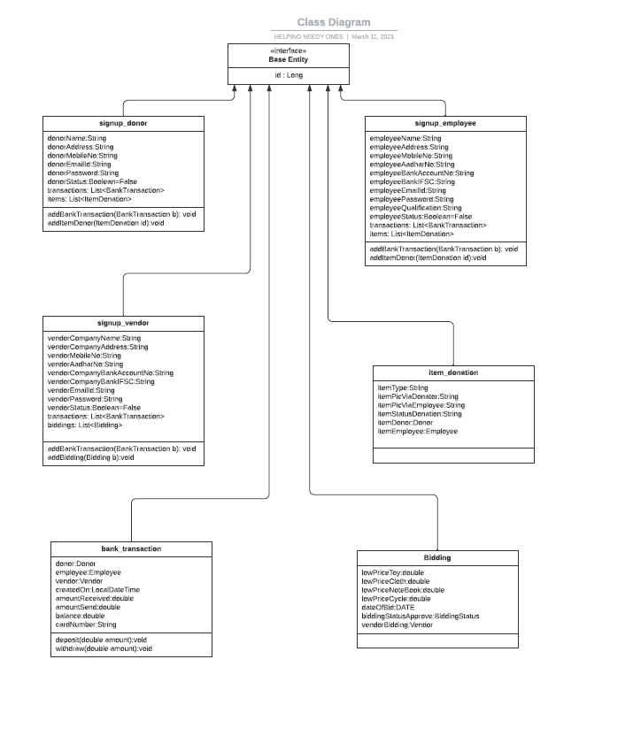

***Figure 3 Class Diagram***

**1 Level Donor DFD Diagram:**

IACSD Helping Needy Ones

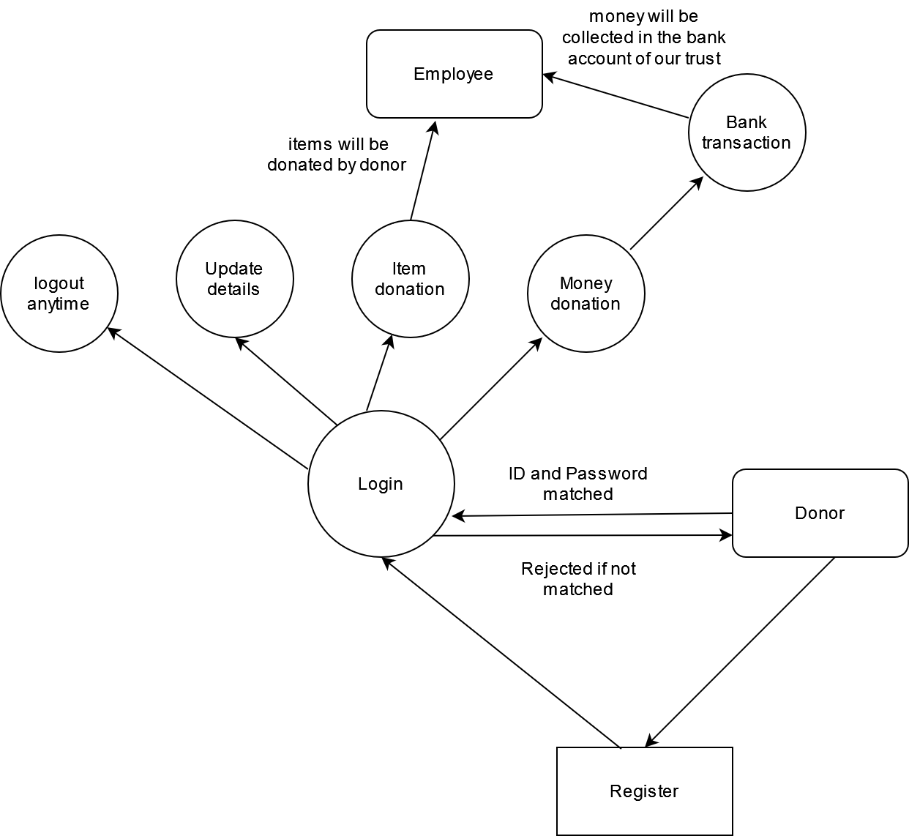

***Figure 4 First Level Donor DFD diagram***

**1 Level Vendor DFD Diagram:**

IACSD Helping Needy Ones

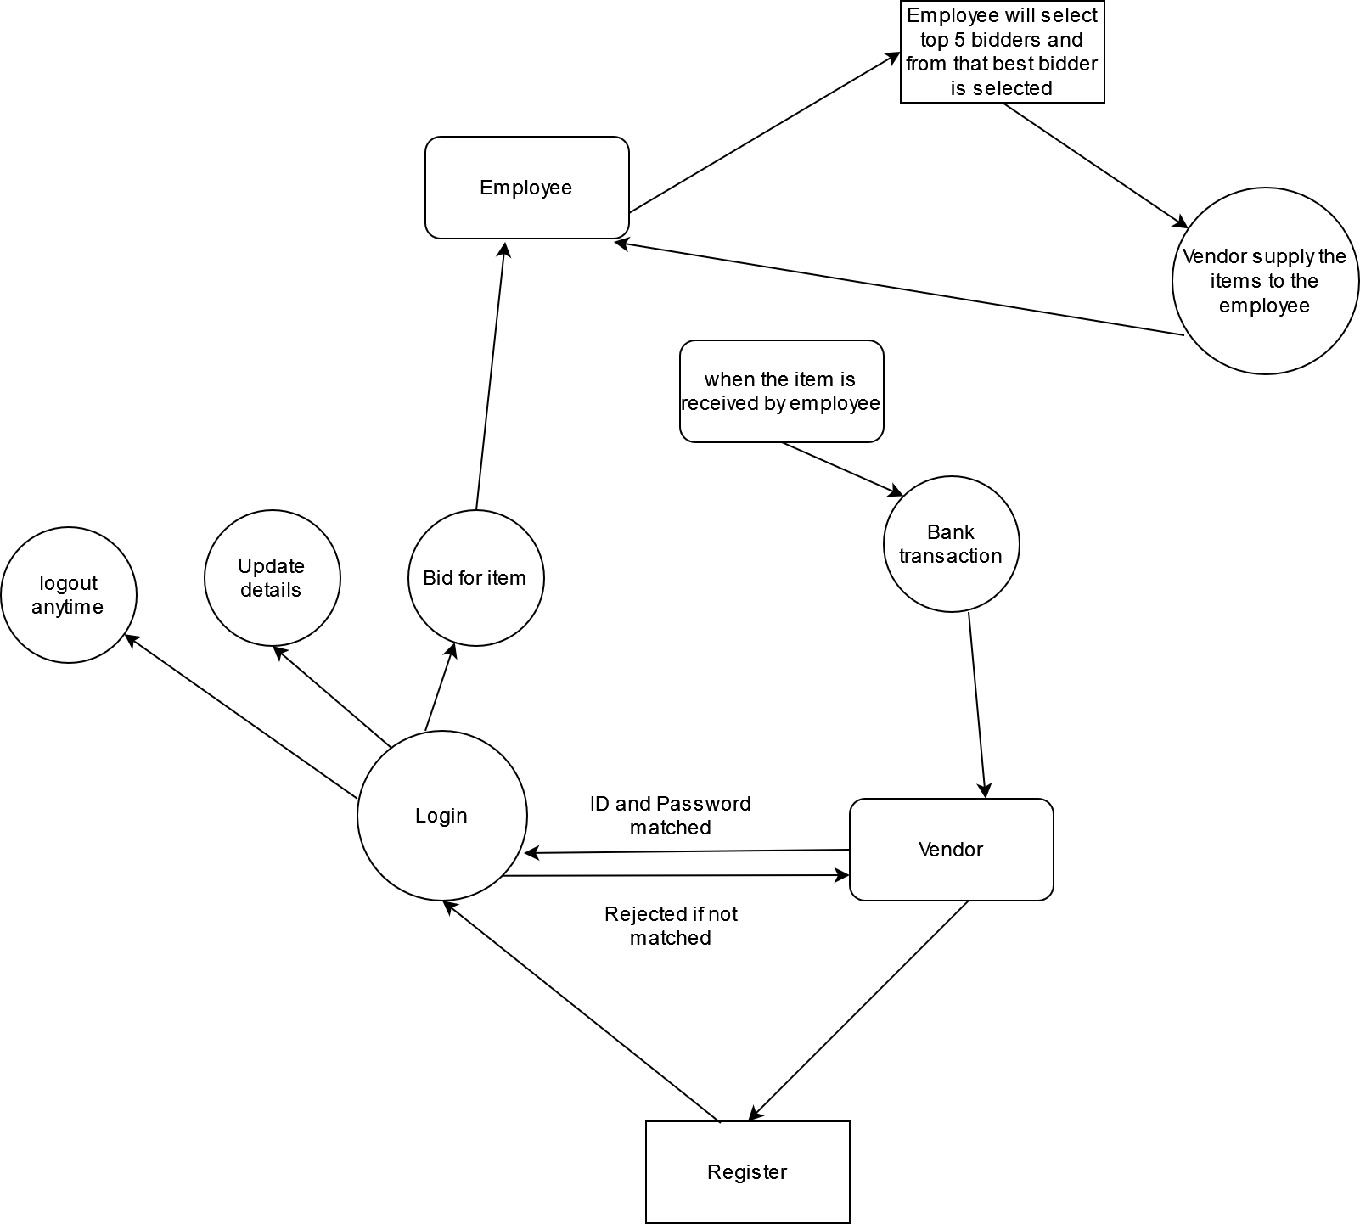

***Figure 5 First Level Vendor DFD diagram***

**1 Level Employee DFD Diagram:**

IACSD Helping Needy Ones

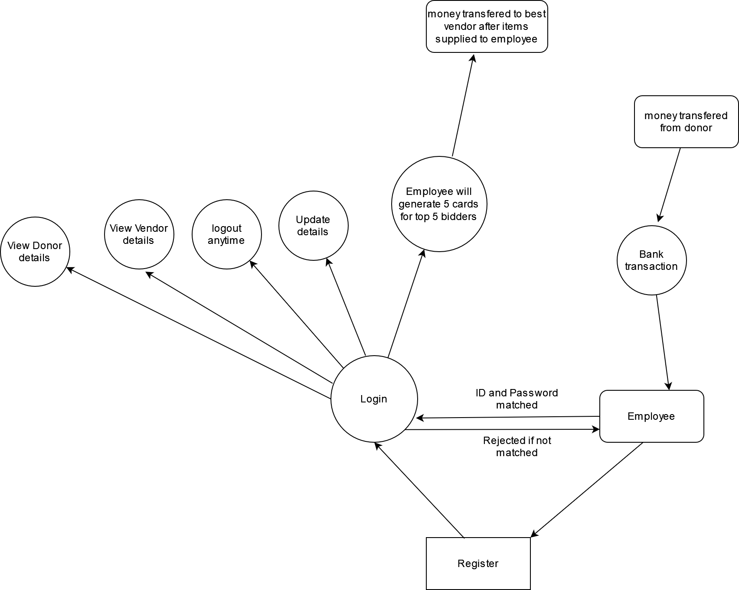

***Figure 6 First Level Employee DFD diagram***

**Activity Diagram:**

IACSD Helping Needy Ones

Anonymous donor activity:

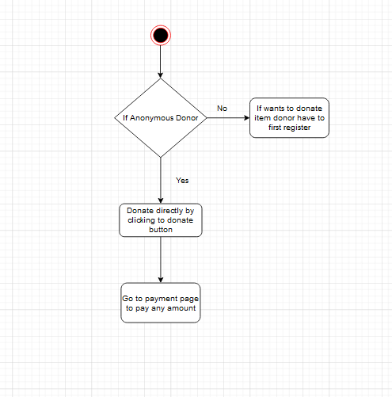

***Figure 7 Anonymous donor Activity diagram***

Donor activity:

IACSD Helping Needy Ones

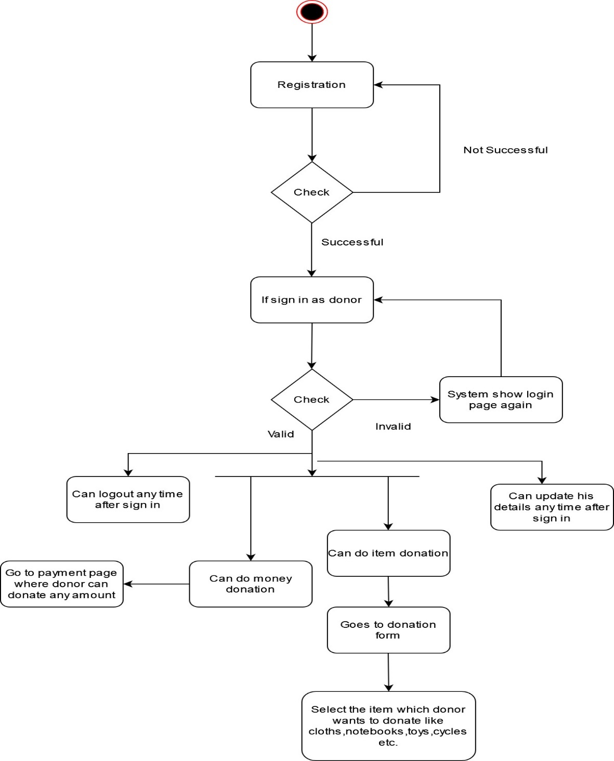

***Figure 8 Donor Activity diagram***

IACSD Helping Needy Ones

Vendor activity:

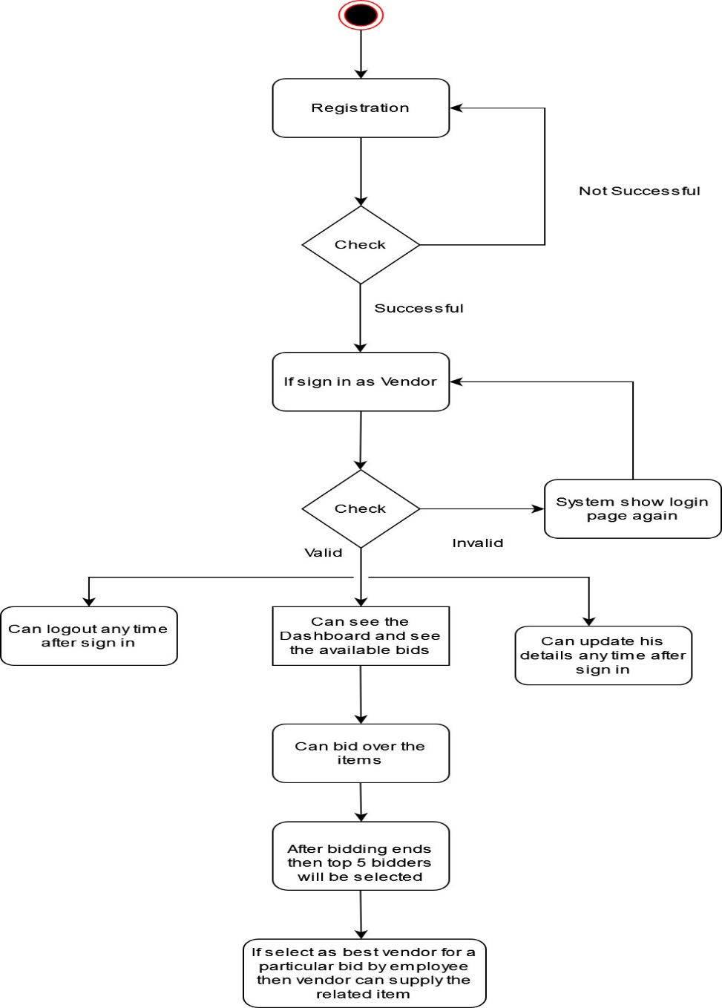

***Figure 9 Vendor Activity diagram***

Employee activity:

IACSD Helping Needy Ones

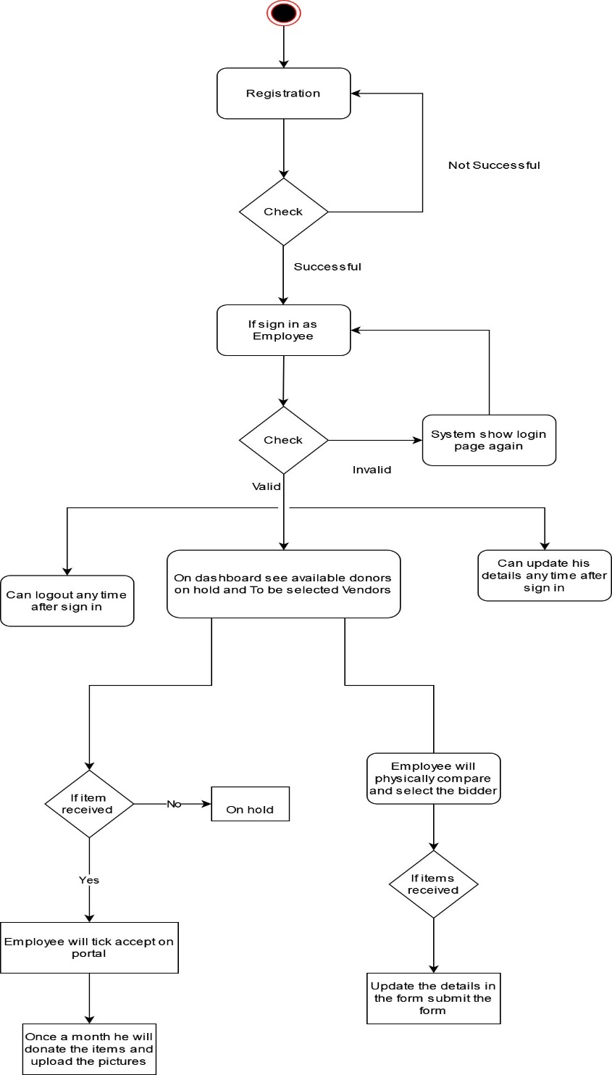

***Figure 10 Employee Activity diagram***

IACSD Helping Needy Ones

**Use Case Diagram:**

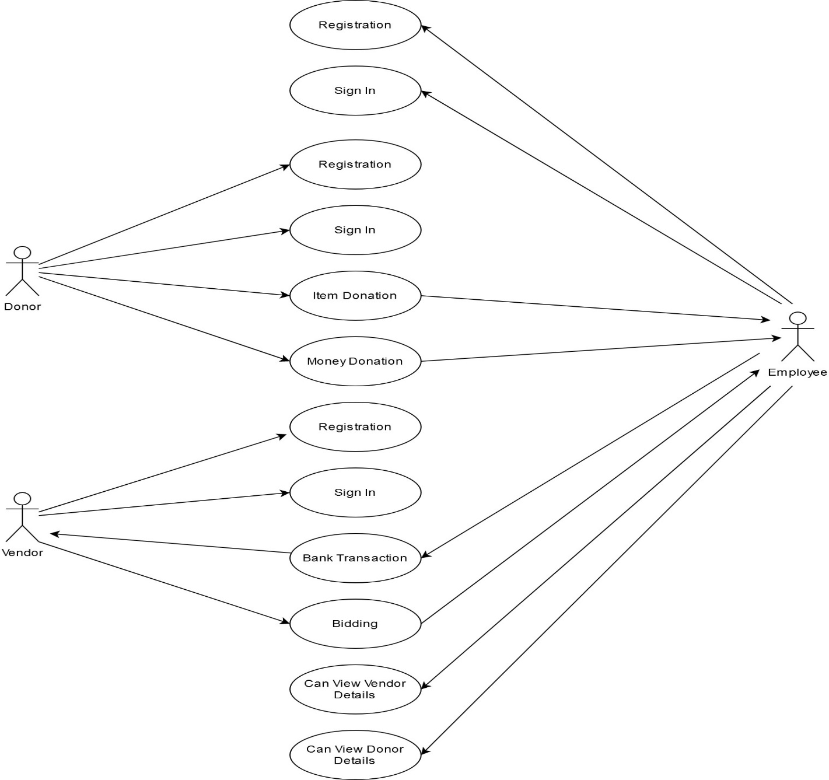

***Figure 11 Use Case diagram***

IACSD Helping Needy Ones

**Sequence Diagram:**

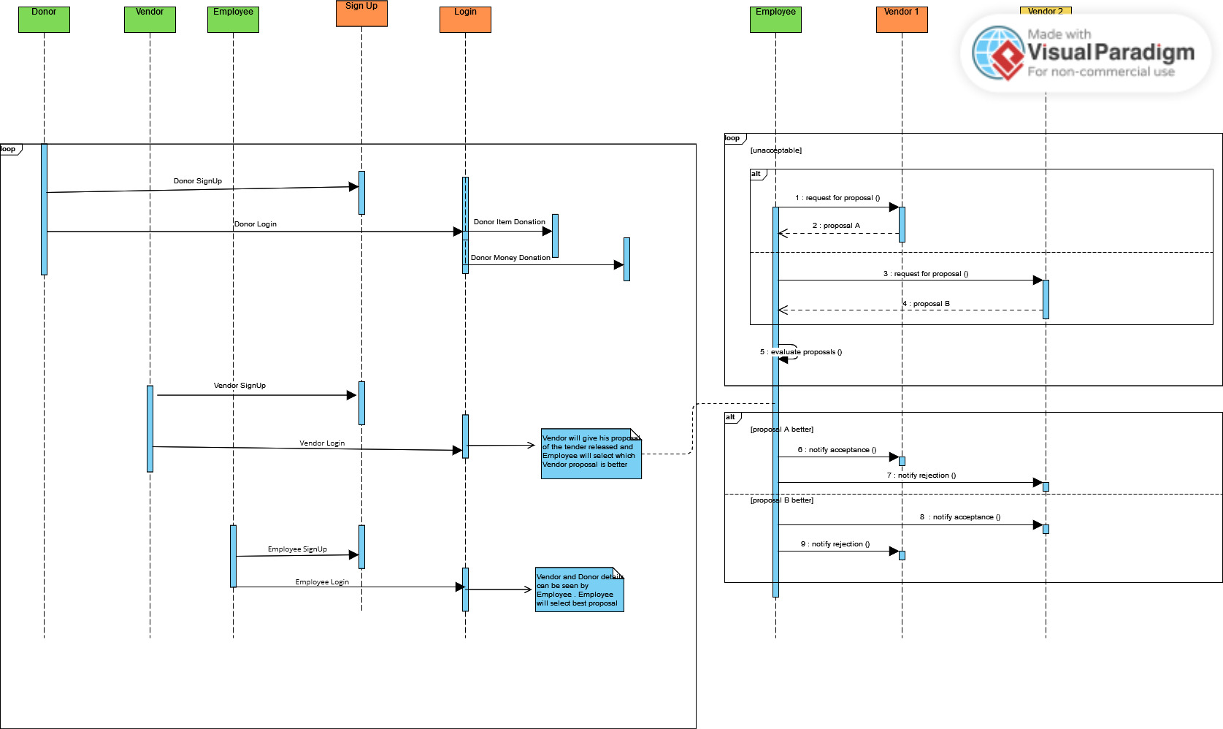

***Figure 12 Sequence diagram***

# TABLE STRUCTURE:

IACSD Helping Needy Ones

**Tables:**

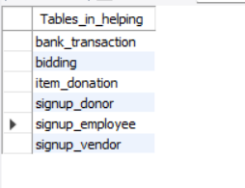

**signup_donor:**

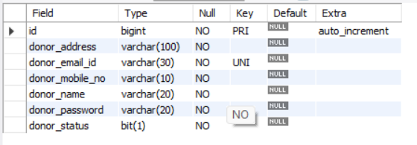

IACSD Helping Needy Ones

**signup_vendor:**

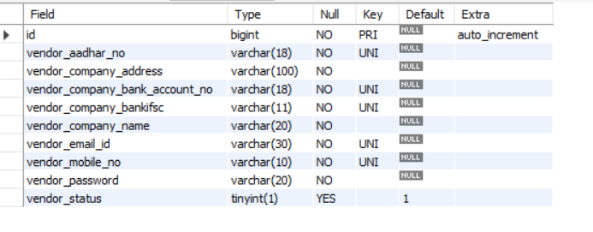

**signup_employee:**

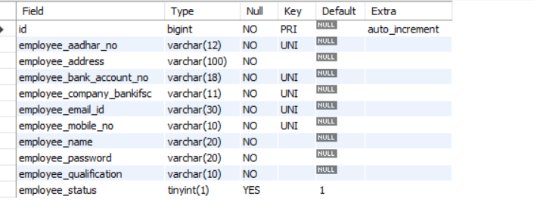

IACSD Helping Needy Ones

**bank_transaction:**

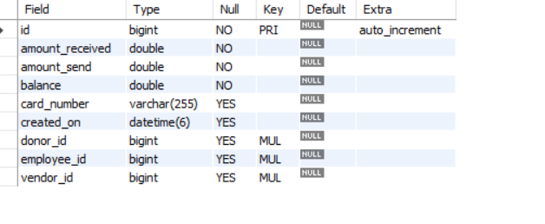

**bidding:**

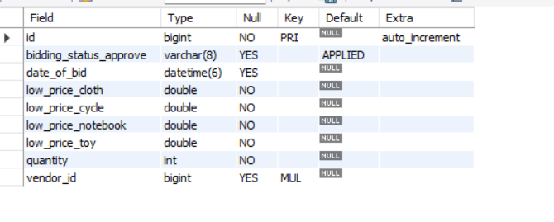

IACSD Helping Needy Ones

**item_donation:**

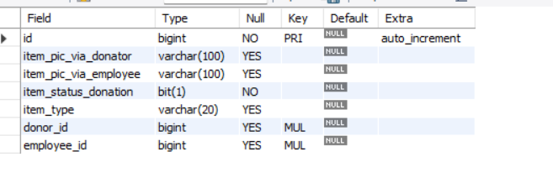

**Project Pages**

**Landing Page**

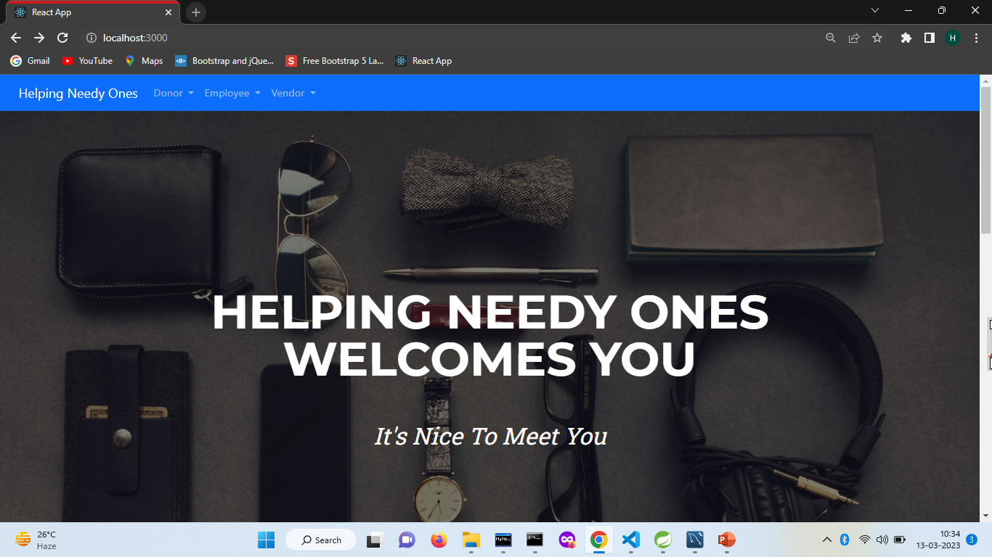

**Donor Registration**

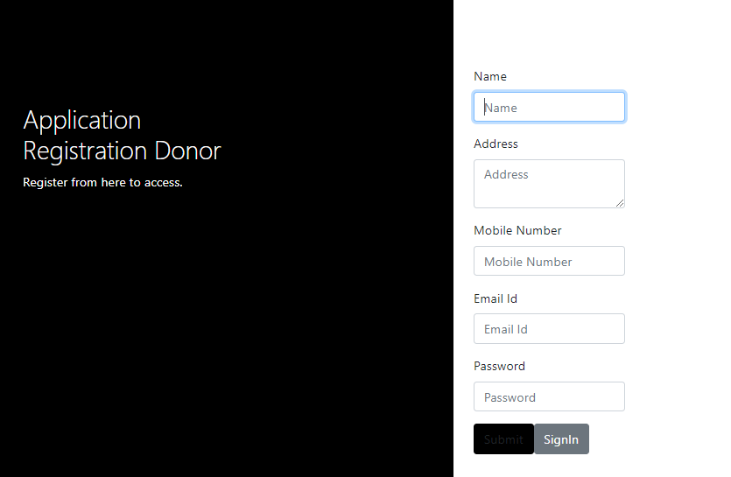

**Donor Login Money Donation**

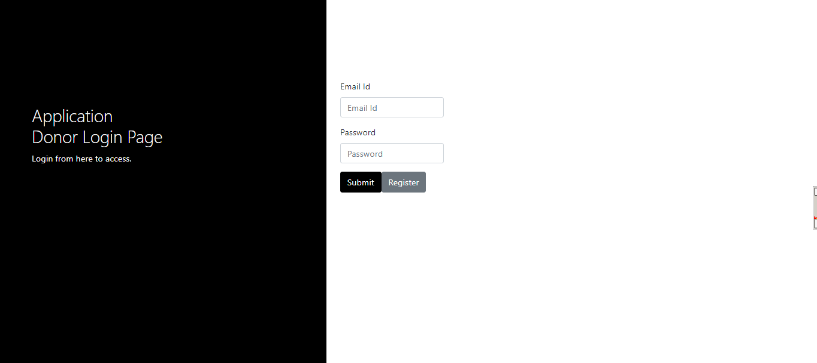 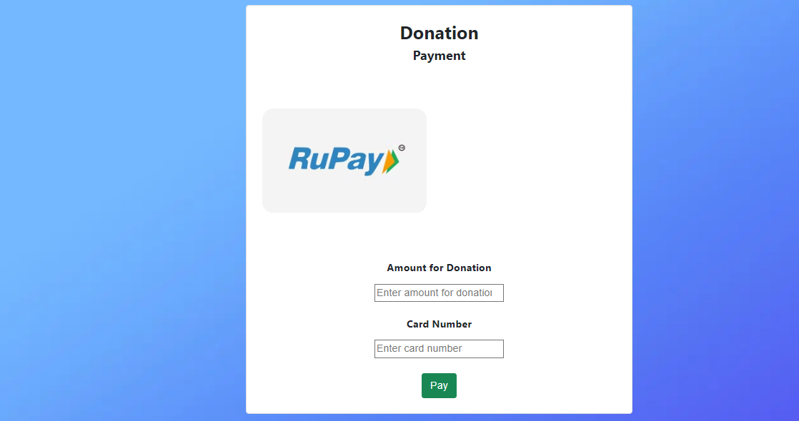

**Donor Dashboard**

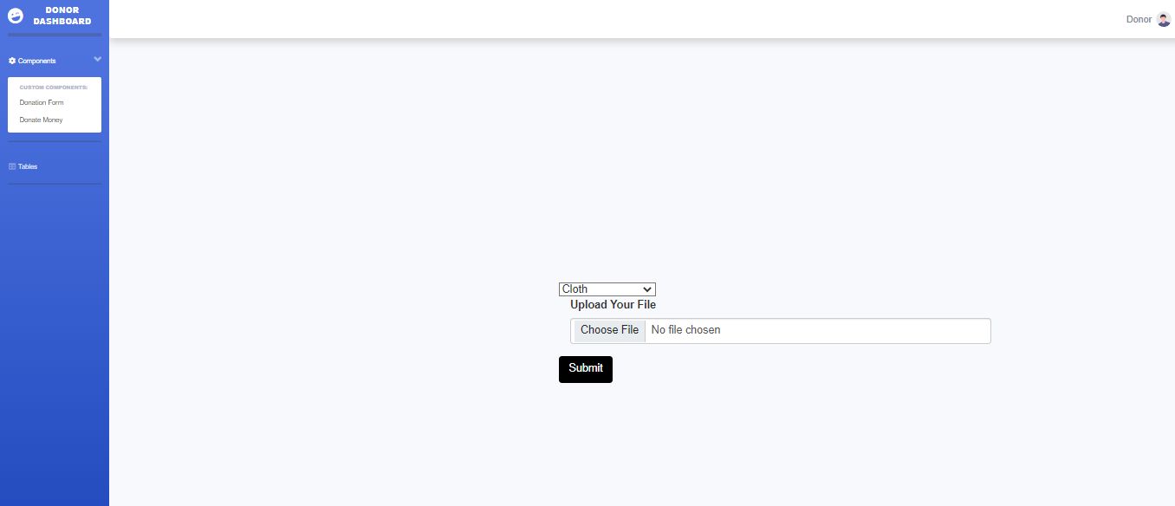

**Employee Dashboard**

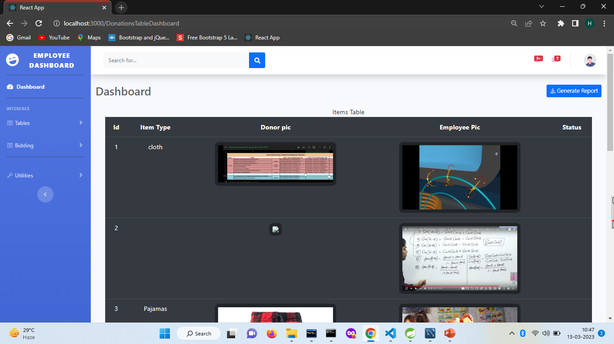

**VENDOR DASHBOARD**

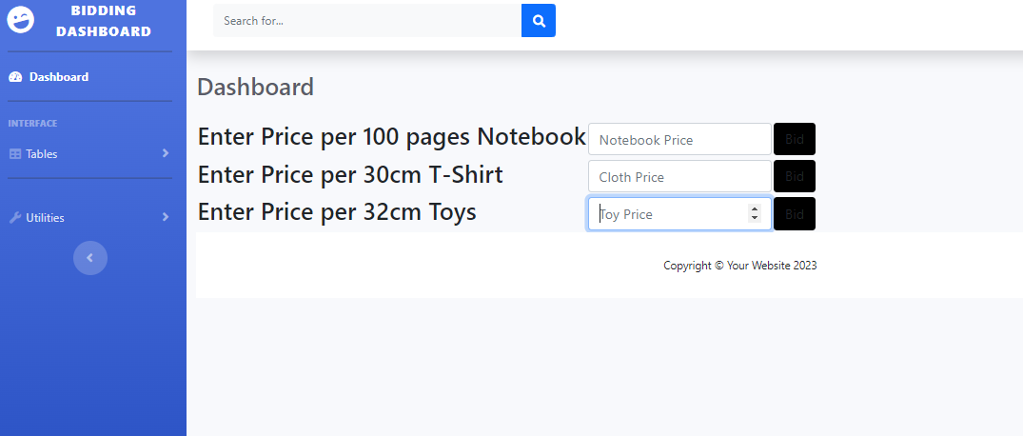

IACSD Helping Needy Ones

**CONCLUSION**

The project entitled **Helping Needy Ones** was completed successfully.

The system has been developed with much care and free of errors and at the same time it is efficient and less time consuming. The purpose of this project was to develop a web application for donating items by donor. This project helped us in gaining valuable information and practical knowledge on several topics like designing web pages using React.js, usage of responsive templates, designing of web applications, and management of database using MySQL. The entire system is secured. Also, the project helped us understanding about the development phases of a project and software development life cycle. We learned how to test different features of a project.

This project has given us great satisfaction in having designed an application which has features of donating items like cloths, books etc., transparency is maintained during vendor bidding, automatic bank transfer done when item received by employee through vendor.

**Future Scope**

IACSD Helping Needy Ones

There is a scope for further development in our project to a great extent. A number of features can be added to this system in future like using virtual and augmented reality technology, organizations could create immersive experiences that showcase their impact and encourage donations. Incorporating crowdfunding features could allow organizations to create campaigns for specific projects and receive donations from multiple donors.

In future we will enhance our security with latest technology and we will make our web application more attractive , fast and responsive so that it would be more appealing for donor or vendor also receipt can be send via email is also will be developed in this project.

IACSD Helping Needy Ones

# 

# REFERENCES

1. JavaScript Enlightenment, Cody Lindley-First Edition, based on JavaScript 1.5, ECMA-262,

Edition

1. Mc Graw Hill’s, Java: The complete reference 7thEdition, Herbert Scheldt
2. Complete CSS Guide, Maxine Sherrin and John Allsopp-O'ReillyMedia; September 2012

## ONLINE REFERENCE

* 1. [www.javatpoint.com](http://www.javatpoint.com/)
  2. www.Baeldung.com
  3. www.tutorialrepublic.com
  4. [www.Google.com](http://www.Google.com)
  5. [www.w3school.com](http://www.w3school.com/)
  6. www.mdbootstrap.com